**Prathap Shankar**

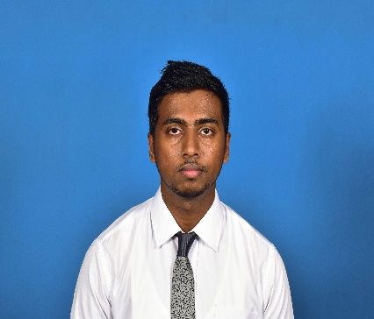61, Anniwatta, Kandy

[Shankarprathap72@gmail.com](mailto:Shankarprathap72@gmail.com)

**Personal Information**

Name in full: Subramaniam Prathap Shanakar

Date of birth: 1st of May 1994

School attended: Trinity College Kandy

Nationality: Srilankan

NIC number: 941223427v

Languages: Tamil, English, Sinhala

Contact numbers: 0771391121 / 0812202056

**Education**

*GCE O/L 2010*

Subject Result

English A

Health Education A

Mathematics B

Science C

Tamil C

Religion C

Commerce S

Art W

*GCE A/L 2013 under Commerce stream (English Medium)*

General English A

Business Studies C

Accounting S

Economics S

**Academic Qualification**

Currently following BBA (special hons) degree at Sri Lanka institute of information technology.

(SLIIT)

CIMA – Currently doing the Certificate level.

**Additional Qualification and Extracurricular Activities**

* Member of both cadetting platoon and the band platoon and participated in the battalion camps which was held at Rantambe from 2009- 2012 and participated in Herman Loos camp on 2012.
* Junior Scout.
* Member of the Mini Rugby Team.
* Member of the Golf Team and I won the Victoria Milo Championship Runners up of Putting and Runners up of 18 Holes.
* Member of the college Athletics team on 2007-2010
* Member of the college swimming squad 2007-2011.
* Secretary of college Hindu student Society on 2012.
* Member of Tamil literary union.
* Member of the Traffic control unit.
* Member of college Radio club.
* Member of Adventure Club.
* Member of 16 Rugby Pool in 2009.

**Team Work**: Took part in group projects at school and other institutes.

**Leadership:** Ability to take responsibilities, motivating others and maintain high Discipline at all times.

I describe myself as ambitious, easy going, honest and a friendly person. I always achieve my goals in an effective and efficient manner, through planning and organizing my tasks.

**I hereby certify that above mentioned information’s are true and accurate to the best of my knowledge.**

Prathap Shankar

09.09.2015